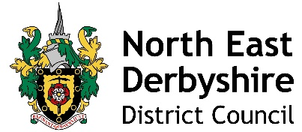

To: ALL PARISH CLERKS |  | Our Ref: | SC/NC/AJB
 |  | Contact: | Nicola Calver
 |  | Tel: | 01246 217753
 |  | Date: | 22 October 2021

Dear Clerk,

The Standards Committee at North East Derbyshire District Council recently considered a new Code of Conduct for Councillors which incorporates best practice from the LGA Model Code and was released at the start of 2021.

The new NED Code of Conduct was agreed at the meeting of Council on 12 July 2021 and is available to view on the Council’s website as part of the Constitution. You may wish to consider whether your Parish Council wish to adopt this new Code of Conduct at Parish level. We would strongly advise you to do so, not just because it the LGA model but more importantly because it makes very clear what is expected of a Member in terms of behaviour.

In order to assist in your understanding and knowledge of the new Code of Conduct, we would like to invite you to one of our training sessions that we are holding. Please see the dates of the training sessions below:

- Monday 8 November from 5:30 to 7:00pm. This session will be held in person at Bolsover District Council in their Council Chamber.
- Thursday 11 November from 12 – 1:30pm. This session will be held virtually.
- Tuesday 16 November from 10 – 11:30am. This session will be held virtually.
- Wednesday 24 November from 10 – 11:30am. This session will be held virtually.

If you would be interested in attending one of these sessions, please contact asher.bond@ne-derbyshire.gov.uk

Yours sincerely,

Cllr William Armitage, Chair of Standards Committee and Sarah Sternberg, Monitoring Officer

